Vancouver Island Minor Lacrosse Commission
Regular Meeting Minutes
May 4, 2026

Attendees
Voting Executive
Chair Andy Stuart
Vice Chair Scott Barillaro
Secretary Krista Gregory
Treasurer Michelle Vecqueray
Zone 6 Representative Adam Gow
Web Master/Scheduler Liaison Jeremy Penzin
Female Coordinator Kate Blass

VIMLC Executive
BCLOA Representative Sarah Dmytruk
Indigenous Development Bryan Baxter (absent)
BCLCA Representative Kelly Fines (absent)
Commissioners Greg Toll, Janice Parmar, Rachelle Noiles, Cathy Coulson

Association Representatives
Alberni Valley Jeremy Penzin
Campbell River Sarah Thomas
Comox Valley Chad Robinson
Cowichan Valley Koltin King
Juan de Fuca Kyla Pedlow
Nanaimo Shawn Swanson
Oceanside Ryan Minty
Peninsula Rod Senior, Simon Upshon
Saanich Scott Barillaro, Katherine Dyrland
Victoria Esquimalt Stacey Santos

- Call Meeting to Order 7:05 pm

- Adoption of Previous Minutes
Motion to adopt previous Minutes made by Michelle Vecqueray, seconded by Koltin King, Carried

- Additions and Adoption of Agenda
Motion to adopt the Agenda made by Scott Barillaro, seconded by Krista Gregory, Carried

- Business Arising from the Minutes none

- Financial Report: Michelle Vecqueray

Current Bank balance is $29,794.69
There are no outstanding bank items.
All associations have paid their first half fees. Thank you!
Attached is the Budget vs Actual statement as at May 1st, and the bank reconciliations for March and April 2026.

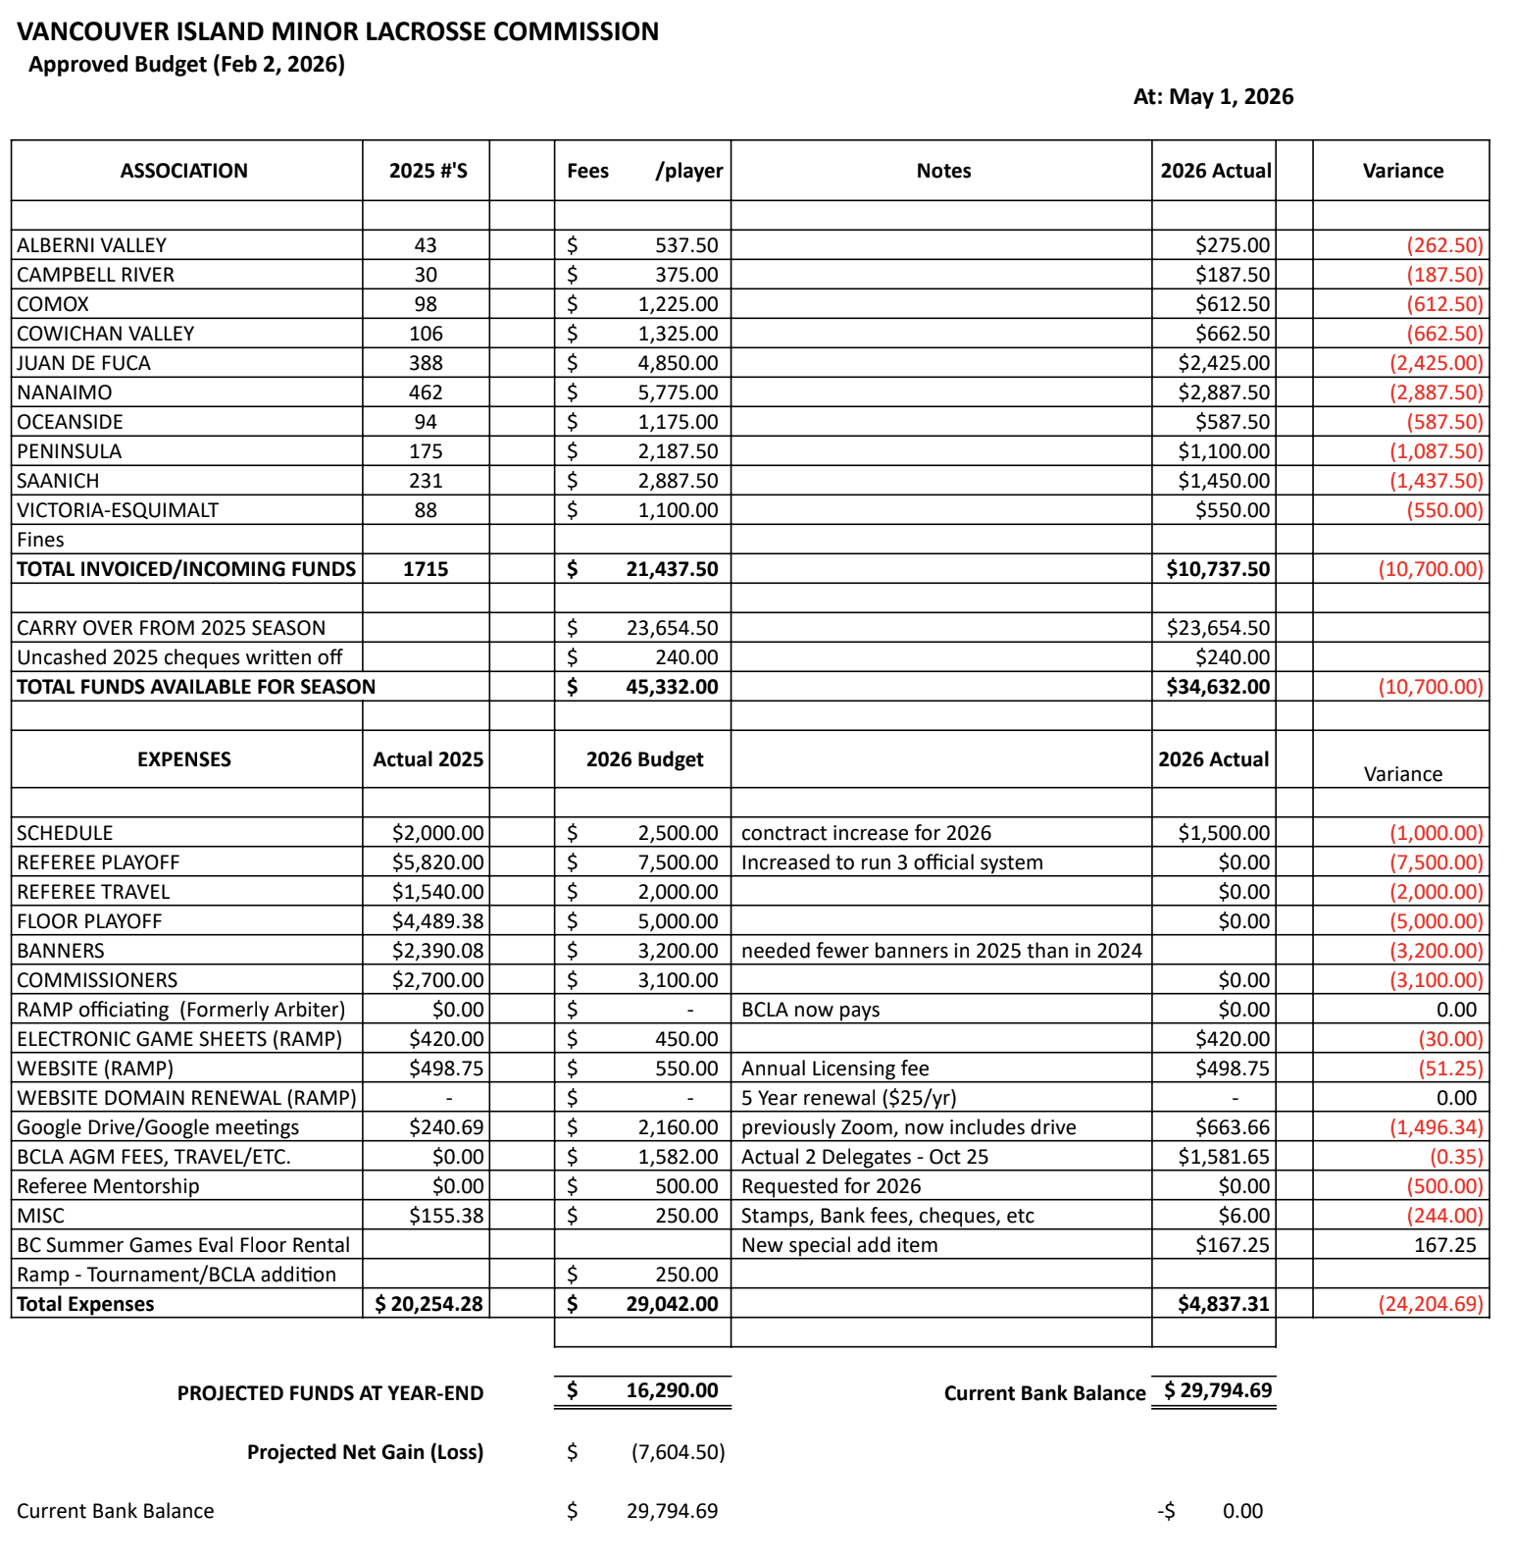

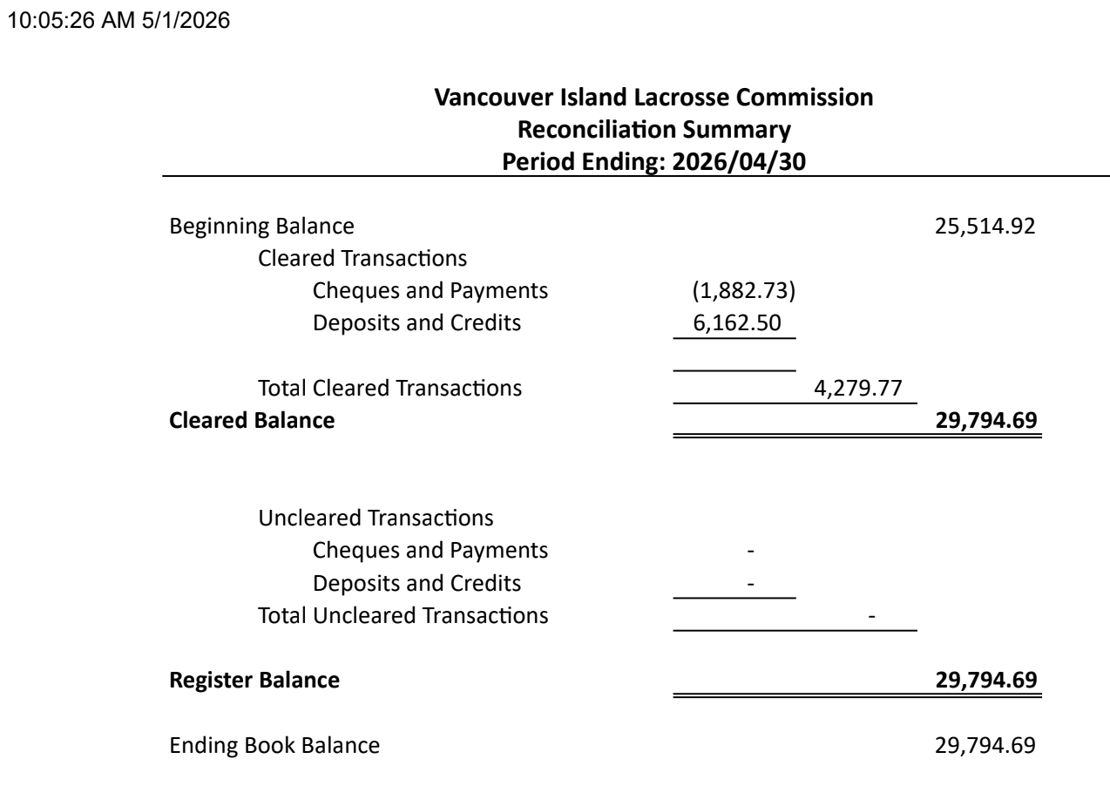

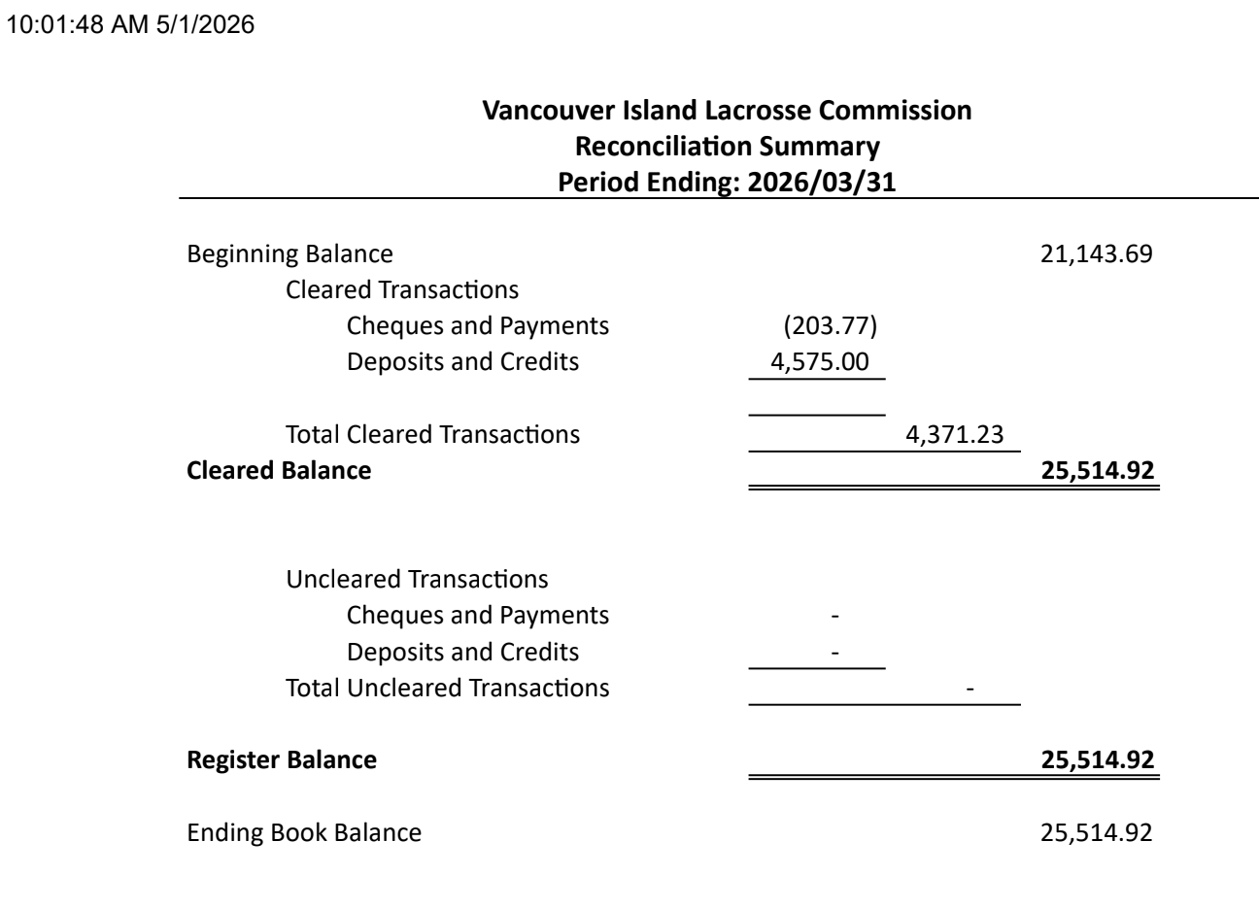
- Zone 6 Reports

- Chair Andy Stuart
No report
- Minor Directorate Rep Adam Gow
There is not much to report as MD has not met since before our last meeting.
Summer Games had our on floor eval last week, we had 33 registered. there are still some tough choices to make so coach staff has asked to view players in their league games. Final selection will hopefully be done within the next couple of weeks.
Thank you to Cowichan for hosting and assisting in getting floor time.

- Vice Chair Scott Barillaro
Overall, the coed schedules are holding together. I understand a flurry of game reschedules occurred once teams were confirmed for tournaments. That is normal. However, I think rescheduling was more challenging that previous years given 1) more teams across all divisions, 2) limited weekend floor time, and 3) the need to get games in before Tiering Break. This led to some challenging scheduling and travel choices. Three or four games were not initially scheduled due to conflicts. Now that the reschedules are done, I will connect with those teams and the commissioners to determine the next steps.

The female schedule has presented challenges on many fronts; both on process and technology. The LMMLC was well behind VIMLC in creating its coed and female schedules. That delayed the draft interlock schedule which drives island schedule planning. Further, BCLA, originally indicated it would not use RAMP's Portal Game function (which allows different Commissions' systems to "talk" to each other) but later changed its mind. We worked with the LMMLC coordinator to use the function only to find it had compatibility issues with the new RAMP platform. This caused confusion and frustration for everyone involved. It also caused several game cancellations. All parties have now reverted back to LMMLC site for all female games (including those on the island), ensuring a single information source for everyone. I am working with the LMMLC coordinator get this up and running. This is necessary to ensure the female season can function but we will need to think hard about this approach going forward.

Jeremy and I sat down with the LMMLC and Thompson Okanagan Commission reps last Saturday to review the BCLA Tournament site and how it works. I am happy to report this works well once you understand it. I set up the Tim White Tournament site over the weekend and then showed Nanaimo volunteers how it works. They have since uploaded the games in all divisions. I encourage teams that will attend to have their managers check their RAMP Gamesheets App to see if the tournament games have shown up yet (they should have). Jeremy and I will host a session for JDF, Oceanside and the Peninsula (and anyone else who wants to learn) about setting up tournament sites ASAP.
The scheduler is on standby should there be movement during the Tiering Break.

Presidents: Please advise Andy (cc'ing me) of your declarations to BCLA once sent. The Minor Directorate does not share them immediately, which delays playdown scheduling. Getting the declarations will help us plan sooner.

- BCLCA Rep Kelly Fines
Nothing to report

- BCLOA Rep Sarah Dmytruk
April went by with the usual early season challenges. Officials have been transitioning to the new rulebook fairly well with a few bumps along the way. As far as getting games covered, we have already had to get creative for the North Island and even rescheduled a few due to a lack of officials. We need to start coming up with a plan for the smaller associations to get more L2 officials so we can better mentor our younger officials as well as ensure we are not having to reschedule U15 and U17 games on a regular basis.
I am also very pleased to report that we have not had any Game Misconducts for Abuse of Officials given to coaches as of yet (knock on wood) and only 2 Game Misconducts for Abuse of Officials to players!
To the presidents, I would encourage you to get your coaches to fill out the Official's Evaluation by Coaches so that we can have record keeping and can work on specific items with officials. This is for both potential items to review/improve on, as well as positive feedback to our officials, especially the younger ones!

- Indigenous Development Coordinator Bryan Baxter
Jesse Kemp has been cleared to deliver CMD Box going forward. I will be unable to attend the meeting as we are heading out of town until June.

- Female Coordinator Kate Blass
Finalizing the interlocking schedule this season has been a significant challenge. We will be organizing some meetings at the end of this season to determine how we, the island, need to move forward next season. We are losing players because the scheduling system we have with the mainland isn’t working.
In happier news, some island coed girls are getting the opportunity to play in the Tim White this weekend on a female team. Thanks to Nanaimo for the opportunity and to Cowichan (Kim) for taking it.

- Web Master Jeremy Penzin
In tonight’s meeting Scott and I will discuss BCLAs rollout out of the RAMP tournament work flow for the 5 tournaments being hosted here on the Island.

- Association Reports
- Alberni Valley
The season is going well, and our teams continue to progress and our new players are adapting well to lacrosse. We have had to reschedule a few games in the older divisions due to shortages of Level 2 officials, but we are managing with the resources that are available.
The U7 and U9 jamborees have been great to maximize play time in these divisions. Alberni is hosting our first U9 jamboree this Sunday (May 10th) and we have two spots to fill if any U9 teams want to play 2 addition games between 10 AM to 1 PM that day. Reach out if you have any questions.
Additionally, three of our team managers have reported sync issues with the RAMP Gamesheets app. We currently have open tickets with RAMP support folks to resolve these technical glitches.

- Campbell River
The season is moving along well overall, though frequent tournament reschedules have put pressure on weekend availability. We’ve started using weekday games with Comox to help ease that, and it’s been a positive shift and helpful with refs
Adding a discipline committee to handle all disciplinary matters for next season in hopes policies are followed appropriately and not ignored. Just working on its policies and procedures
Special thanks to Kyla for sharing JdFs policies with me!

- Comox Valley
This season we are running with more players and teams than we have had in 10 years. We’ve had some challenges with ref availability but haven’t had to move too many games so far.
Our players and coaches have adjusted to the rule changes and I haven’t heard any questions or complaints about how the games are being called.
The jamboree style schedule for u9 is working well for our players and parents. I think this format is the best option for this age group going forward.

- Cowichan Valley
We’ve had some issues with parents this season in our younger age groups which has been a challenge. It’s really had our association re evaluate our policies etc.
We also had some kids quit at the u7 age level that’s impacted our association declarations. So that has been challenging.
We successfully just hosted our first u11 tournament this past weekend which was a great turn out, and a lot more work than I anticipated. Huge thank you to the u11 South commissioner for all her hard work. We could not have done it without Penelope.
We also had some issues with our website, as we didn’t get the website upgrade which caused some issues with RAMP.
Fortunately everything seems to be running smoothly now.

- Juan de Fuca
We have had a ton of games we’ve hosted over the last few weeks which has been great to see! Our refs are getting lots of games in, and they’ve even had the chance to travel to help out other associations. All of our U11-U17 games have used a three ref system, which has been great with the rule changes and with keeping games under control.
We have rewritten our Discipline Process and are quite proud of how it turned out! Unfortunately, we are in the process of having to use it, so we will see first hand how it works. While on the topic of poor behaviour, we have had a couple of games where a select few JDF spectators have not been behaving as they should be at away games. An association wide email was sent out last week reminding parents of what our expectations are, and one parent was sent a warning letter. We are doing our best to have zero tolerance for this behaviour.
Sunday April 19th we hosted Team BC tryouts at JDF Arena.

May 22 - 24 is our Travis Bateman U11 tournament. We have 14 teams attending the tournament, over two divisions. Mostly Island teams and also a Vancouver and Surrey team. This tournament will also be using the three ref system for all games.
We have been in contact with Andy from Event Connect to help us secure hotel room blocks for our 2027 tournaments. We had a lot of interest from mainland teams this year, however the cost of hotel rooms was around $400 per night, so most of those teams cancelled unfortunately. Andy will start to contract hotels in July of this year, in hopes that we can get the best rates possible.

- Nanaimo
The season is well underway, and overall things are running smoothly within NDLA.
The female interlock schedule continues to present challenges and has been a significant strain on our athletes. It’s something we’ll need to keep monitoring and, ideally, look at ways to better support moving forward.
The implementation of the new rule set appears to be settling in. Both officials and coaches have done a good job adapting, and we’re seeing more consistency week over week.
Our focus right now is on the upcoming Tim White Tournament this weekend. There’s a lot of excitement around the event, and we’re looking forward to hosting.

- Oceanside
All teams are rolling and playing games.
I am hearing a lot of difficulties on finding floor space for make-up games because of tournaments but sounds like they are getting figured out.

- Peninsula
As we all are abundantly aware it’s a lot of work leading up to the season but now that it’s rolling it was worth the effort. Naturally there have been some bumps along the way but overall it is going pretty good thus far.
We have once again had a lot of interest in our U7/U9 Father’s Day Tournament which is very encouraging and will have a total of 28 teams involved this year.
Lots of tournaments have caused schedule juggling but I think we are getting that sorted now.

- Saanich
The season is off and running. Hard to believe the first month is gone already.
So far, so good. All of our teams have played games and I am not aware of any glaring issues (which is nice). We will get access to Pearkes on May 9 and look forward to hosting teams on our home floor. I believe those teams that needed to reschedule games have done so and their tournament plans are in place. I repeated my message to our teams that they need to be very sure about declarations this year and have plans in place given their locations. My hope is that things continue along the same path as the first month.

- Victoria Esquimalt
Many of my presidential woes match those as Female Rep regarding the interlock.
We received some reports of unacceptable team behaviour which we are looking into now.
Coed is having a great season so far. We are sad we can’t host our U9 tournament this season but we are already planning for next season.

- Commissioner Reports
- U7 South
There have been 17 games so far. I have made my way to a few of them. The ones I have attended everyone seems to be having fun and the games seem to be running as smooth as you can expect in this division.
I have had one reschedule due to a double booking.
Most teams have added their rosters to ramp and had no issues. I've had a few that have struggled to get their coaches NCCP numbers listed. I'm hoping that I will see all numbers listed for next weekend's games.
Unfortunately, lots of teams forget to mark their games as completed at the end of the game. I have sent out emails addressing this, and I noticed this past weekend some teams were on top of it, but there are still a few who have yet to mark their games as completed.
I will send out another email, reminding teams of this.
As far as I understand one of the teams in Cowichan has unfortunately dissolved. The schedule is being re-looked at and adjusted to accommodate this. I believe a few games this past weekend was cancelled due to this situation, but unfortunately, I was not made aware of which ones. I'm just going by the games that involved the Cowichan 1 team.

- U7 North no report
- U9 South
Looks like 33 games played. Some say completed and some do not. Are they all supposed to show as completed?
- U9 North
U9 North has had a total of 21 games played. I have not yet been asked to reschedule any games. I’m still waiting on contact information for a couple of teams. I’ve sent multiple emails to presidents and haven't had a reply. The biggest issue I've come up against so far is new managers not using ramp properly. Kids not being put into the gamesheets, and if they are in ramp they’re not being marked as attending. I’ve also noticed in most cases that games are not being marked completed as well as verified. I believe I only have 2 games that have a refs name listed. I plan this week to send out emails to address this. However, it is difficult when I still don’t have all contact information

- U11 South no report
- U11 North
Things are rolling along. The U11A group has had 4 league games which has resulted in only 2 majors
U11B has over a dozen league games with 7 Majors. One player suspended for a Major in the last 5 minutes and one coach that had two games added to his suspension for serving on the bench while suspended.
With High Sticking now a major penalty I expected more majors. There does seem to be too wide of a gap with place and push as opposed to hitting that could be addressed next season in referee and coaching clinics. It is confusing for the players if they get away with it one game and not the next.

- U13 no report

- U15
April was a busy fun month, I have made it out to a number of games.
15A has 4 teams 2 A1 and 2A2 they have played against each other a total of 11 games, one suspension and 15 majors
U15B has 7 teams playing a total of 21 games, 3 suspensions, 19 majors and 2 carryover suspensions.
Oceanside was off this weekend to Kamloops for a tournament.
Next week Nanaimo hosts the Tim White tournament which I will be commissioner for as well.
We have rescheduled all games successfully.
I have sent out an email about tiering to head coaches and presidents to see how they feel about where their U15 team is positioned.
All u15B teams seem to be evenly matched with no outstanding blowouts.
U15A1 seems to be placed right however not may JDF Saanich games together as of yet to compare.
U15A2 are pretty evenly matched to each other.
We have had a few minor hiccups with RAMP game sheet but hopefully we have gotten through the worst of it.

- U17
As of May 2nd:

There have been 13 game changes so far.

A - 8 games, 5 majors (2 of the 5 in tournaments), 2 suspensions (both for majors in the last 5 in tournaments)

B - 14 games, 15 majors, 7 suspensions (total of 17 games)

All of the suspensions are to players. Eight of the majors were for High Sticking, four of them for fighting.

Scores show a large gap between A1 and A2, similar to past years.

In B there is a significant gap between the last place team and the rest of the division.

- Female
Wow!
What a bizarre start to the season.
Games have started.
A ton of glitches and struggles.
That's all I have to report.

- New Business
- 2026 League Schedule - Update Scott
Please refer to vice chair report

- Tiering Dates - Update Andy
The VIMLC will meet May 10 to review tiering placements and send out any changes to association presidents by May 14.

- Tournaments - Update Scott & Jeremy
RAMP training session will be coming for commissioners, Ref allocators, tournament coordinators and other association reps.

D. Key BCLA Dates - Update Scott
May 15, last day for play downs/releases to be sent to BCLA
June 1, last day for team movement

E. Provincial Declaration Date – Andy
Provincial declarations need to be to the BCLA by May 25. Please also email Andy and Scott which teams in your association are declaring for provincials as sometimes there is a delay in the BCLA sending out this information, which is needed for planning play downs.

F. Coach Clinic – Andy
Jesse Kemp can now deliver clinics as well. Please email Andy with how many people in your association still need a clinic.

- Next Meeting: Monday, June 1, 2026 at 7 pm

- Motion to Adjourn at 7:30 pm

